Learning What Matters: Graph-Based Recommender System for a Personal News Digest
EM 626 AI/ML for Systems – Engin Deniz Dogu

Problem and Goal
- Idea: Build a graph-based recommender system from a list of sources (RSS feeds, online blogs etc.) users have.
- Problem: Feed readers like feedly.co or rss.app solve collection, but the reader still has to filter hundreds of items by hand or set filters manually. This system follows a reader’s saved sources and delivers only what matters to that reader, learning from simple feedback: more like this, neutral, or show less.
- Goal: Test whether graph structure improves relevance prediction over item text alone, using only the reader’s ratings (no profile or personal information).

Pipeline
Pipeline summary:

sources → collection → LLM enrichment → relevance model (graph) → digest, and reader's feedback

- Set sources: 5–10 RSS/Atom feeds.
- Collect (code): Fetch and parse the feeds (historical backfill plus daily new items); save items.
- Enrich (LLM + code checks): Create a fixed topic list (~30-topics) and generate entities for the graph using an LLM.
- Manual labelling: Rate posts using three classes (more like this, neutral, show less).
- Embed: Title + summary before training.
- Build the graph (code): Graph nodes: items, sources, entities and topics. Save the graph and its statistics.
- Split & Train: Split by time into train, validation and test. Train graph models and non-graph baselines.
- Evaluate: Evaluate using test set, compare with baseline models.
- Feedback: A digest note for the reader and the system engineer (what to show or hide, which sources to adjust), drafted by an LLM from the model's outputs and checked claim by claim.

Graph Learning and Evaluation
- Task: Node classification of items (3-class and binary "more like this" vs. rest).
- Models: GCN/GraphSAGE baseline; HGT or TransformerConv with edge types; attention weights for explanations.
- Baselines: Logistic regression and gradient-boosted trees on the same item features (no graph); label propagation.
- Protocol: Time-based train/validation/test split; 5+ seeds, mean ± std; macro-F1 and PR-AUC (relevant items are rare). Labels are human ratings, so no graph metric is used as both label and feature.
- Ablations: With/without entity, topic and similar-story edges, to show what each kind of edge adds.

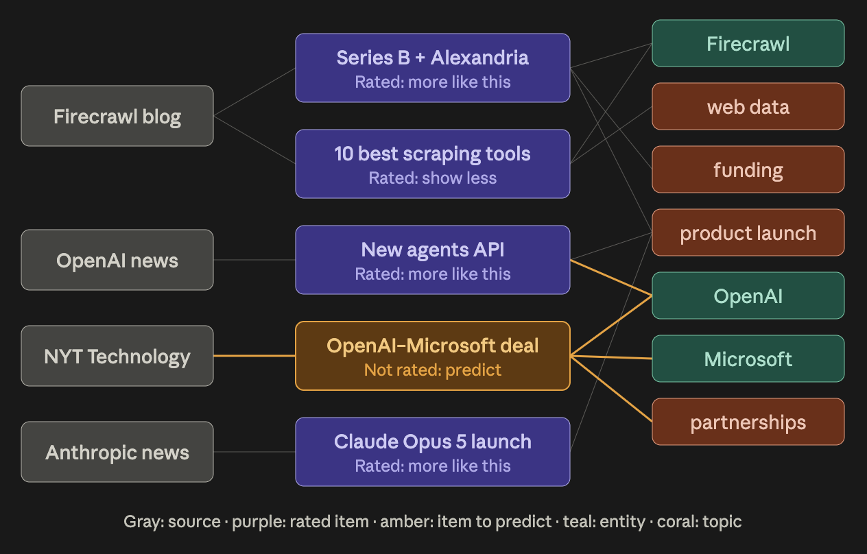
Example graph representation. Purple nodes are blog posts or news items. Figure generated by Claude.

